**CISC320 Algorithms** Your name: __________________________________

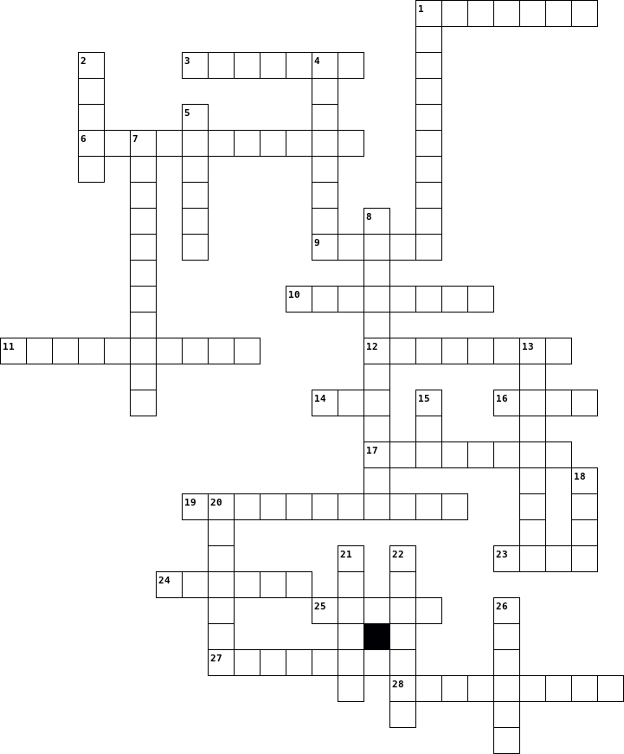

## Clues

|  |  |  |  |  |  |  |  |  |  |  |  |  |  |  |  |  |  |  |  |  |  |  |  |  |  |  |  |  |  |  |  |  |  |  |  |  |  |  |  |  |  |  |  |  |  |  |  |  |  |  |  |  |  |  |  |  |  |  |  |  |  |  |  |  |
| --- | --- | --- | --- | --- | --- | --- | --- | --- | --- | --- | --- | --- | --- | --- | --- | --- | --- | --- | --- | --- | --- | --- | --- | --- | --- | --- | --- | --- | --- | --- | --- | --- | --- | --- | --- | --- | --- | --- | --- | --- | --- | --- | --- | --- | --- | --- | --- | --- | --- | --- | --- | --- | --- | --- | --- | --- | --- | --- | --- | --- | --- | --- | --- | --- |
| |  |  | | --- | --- | | **Across** | | | **1.** | A well-specified description of the complete set of instances, solved by an algorithm. | | **3.** | A type of language that can be used to express algorithms in a loose style. | | **6.** | A reordering of an existing collection. | | **9.** | A fixed-sized ordered collection of distinctive items. | | **10.** | A type of problem where the answer is a yes or no. | | **11.** | A property of algorithms indicating how much time or memory is needed. | | **12.** | A single input and its matched output for a problem. | | **14.** | The best dog. | | **16.** | A single instance or set of instances for a problem. | | **17.** | A pair of numbers indicating a range. | | **19.** | A property of algorithms indicating whether or not they satisfy all instances of a problem. | | **23.** | A collection with hierarchy and parent-child relationships between elements. | | **24.** | The specific values or desired characteristics of the values provided in a problem. | | **25.** | A formal, persuasive explanation of why an algorithm has a certain property. | | **27.** | An ordered collection of generic items with the same type. | | **28.** | A proposed solution to a problem. | |  | |  |  | | --- | --- | | **Down** | | | **1.** | A type of language that balances expressivity with flexibility. | | **2.** | A collection with edge relationships between nodes. | | **4.** | Someone who solves problems. | | **5.** | An arithmetical value representing a quantity. | | **7.** | A property of algorithms indicating how easy they are for humans to understand. | | **8.** | A type of problem where there is a best solution among alternatives. | | **13.** | A symbol in a language. | | **15.** | An unordered collection of generic items with the same type. | | **18.** | A language where algorithms are expressed so formally that a computer can execute them. | | **20.** | The specific values or desired charactierstics of the values expected from solving a problem. | | **21.** | An ordered collection of characters. | | **22.** | A value that is either true or false. | | **26.** | A type of problem where the output is an element of the input. | |